**Table of Contents**

Introduction1

Overview of the Project2

Scope3

Diagrams

Star Schema

Table Definitions

Flowchart

Data Flow Diagram

Hierarchical Input Process Output

Use Case Diagram

**Introduction**

Grading system, a standardized measurement for various degrees of accomplishment in a course, is the process of grading in education. In general, grading systems are used by educators to assess student performance on standard scales, which are based entirely on points and comprise grades like A-F or ranges like 1-10; typically, letters and numbers are used to denote the grades of students. The grading system's purpose is to provide students with feedback so they may take control of their learning.

Some universities in the Philippines use a 5-Point Scale. In this system, a grade ranges from 1.00 to 5.00, with 5.00 denoting a failing grade and 1.00 the highest, as well as a curriculum weighted average. For Senior Highschool level and below, a uniform and competency-based grading scheme is used in the K–12 Basic Education Program. The weighted raw score of the students' summative assessments will serve as the basis for all grades. The advantage of a grading system is that it will reduce the misclassification of students based on their grades. High achievers won't engage in toxic rivalry anymore. The student will have more freedom and less social pressure as a result. It will result in an emphasis on creating a better learning environment.

**Overview of the Project**

Asd

**Scope**

Login Module – This module checks the username and password, then redirect the user to access the modules.

Grades Module – This module is what the teachers can access, and it is where they can input the grades of each student that they teach. This is also where they can import and export the gradebooks an export grade cards for the students. This module also generates a grade report.

Assistant Teacher Module – This module is where the assistant teacher can view the grades of each student and the grade reports.

Registrar Module – This module is where the registrar can add students, teachers, assistant teachers, subjects, and sections. It enables the registrar to assign sections to student and assign subject/s to teacher/s and students. It also generates an enrollment report.

Admin Module – This module is only for the admin; this module has access to all the modules and reports. This module is where the admin can add a registrar.

**Diagrams**

**Star Schema**

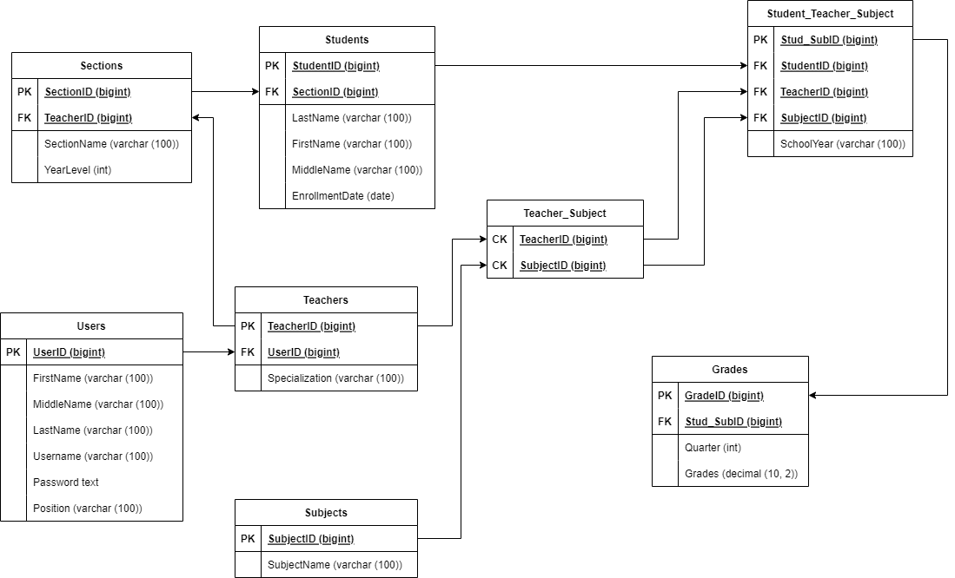

Figure . Star Schema

**Table Definitions**

The table definition defines the database objects that contain all the data in the database of our system. The primary key data type that is used for our table is mainly big integer and the variable character data type that we use has 100 maximum characters. Users table consist of UserID that serves as the primary key for the table, first name, middle name, last name, username, position of the user that is in data type variable character. And lastly, the password as text data type. Teachers table consist of TeacherID as the primary key for the table. The Teachers table has a foreign key UserID from the primary key UserID in Users table. Lastly, is the Specialization with a data type variable character. Sections table consist of SectionID that serves as the primary key for the table. The Sections table has a foreign key TeacherID from the primary key TeacherID in Teachers Table. SectionName that is in variable character data type. And YearLevel with a integer data type. Students table consist of StudentID as the primary key for the table. The students has a foreign key SectionID from the primary key SectionID in Sections table. Last name, First name, and Middle name with a variable character data type.And EnrollmentDate with a data type date. Subjects table consist of SubjectID that serves as the primary key for the table and, SubjectName with a variable character data type. Teacher_Subject table has two (2) composite key columns. First is the TeacherID from the TeachersID table. And the SubjectsID from the Subjects table. Student_Teacher_Subject table consist of Stud_SubID as the primary key. The Student_Teacher_Subject has three (3) foreign key columns. StudentID from the primary key StudentID in Students table, TeacherID from the primary key TeacherID in Teachers table, and SubjectID from the primary key SubjectID in Subjects table. It also has a column SchoolYear with a variable character data type. Grades table consist of GradeID as the primary key. The Grades table has a foreign key Stud_SubID from the primary key Stud_SubID in Students_Teacher_Subject table. It also consist of Quarter with a integer data type and Grades with a decimal format 10, 2 data type.

**Flowchart**

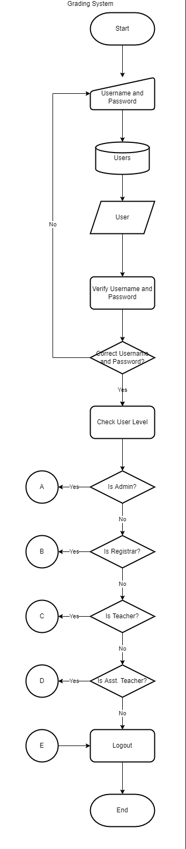

Figure . Grading System

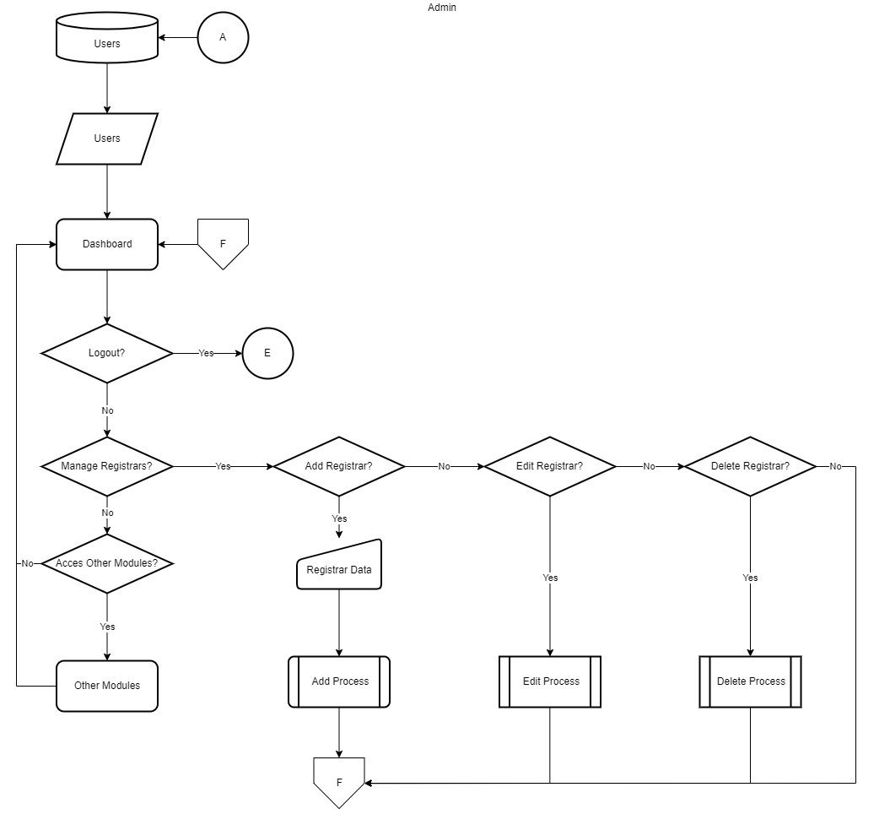

Figure . Admin Module

Figure . Registrar Module

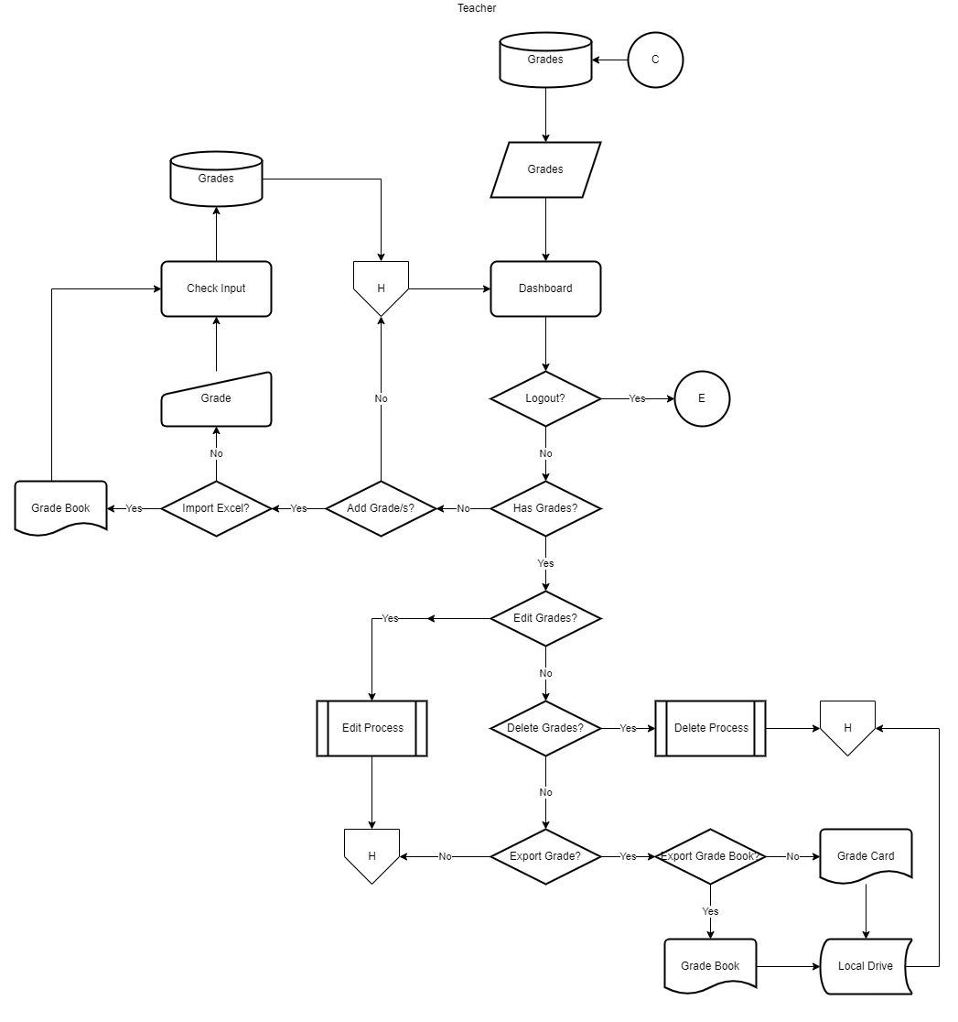

Figure . Teacher Module

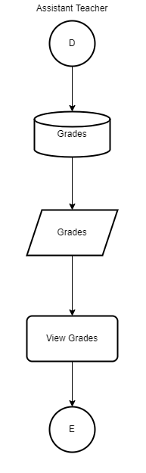

Figure . Assistant Teacher Module

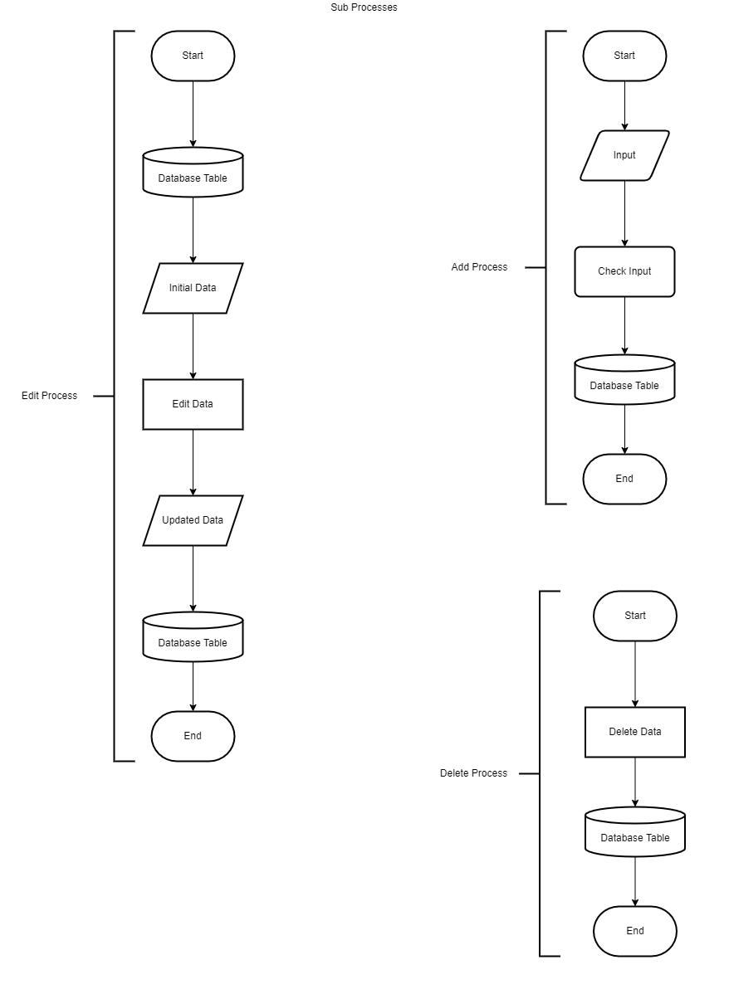

Figure . Sub-Processes

**Data Flow Diagram**

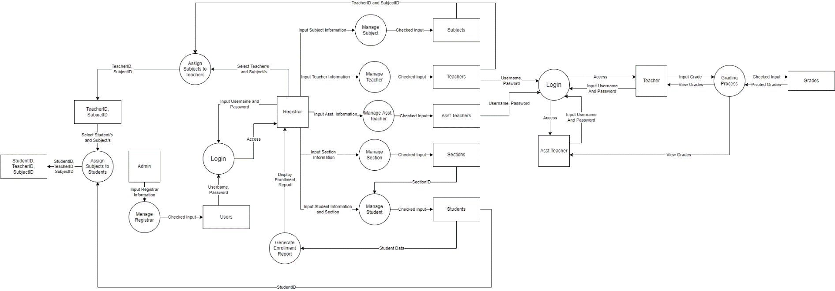

**Hierarchical Input Process Output**

Asd

**Use Case Diagram**

Asd